The sale of a main home is generally not a reportable event if:
- Residence was main home
- Taxpayer satisfies ownership and use tests
- Gain less than $250,000 ($500,000 MFJ)
- Taxpayer did not receive
Form 1099-S

Report the sale or exchange of your main home as a Capital Gain or Loss if:
- You can’t exclude all your gain from income, or
- You received a Form 1099-S for the sale or exchange.

Generally, if you meet the following two tests, you can exclude up to $250,000 of gain. If both you and your spouse meet these tests and you file a joint return, you can exclude up to $500,000 of gain (but only one spouse needs to meet the ownership requirement in Test1)
- Test 1. During the 5-year period ending on the date you sold or exchanged your home, you owned it for 2 years or more (the ownership requirement) and lived in it as your main home for 2 years or more (the use requirement).
- Test 2. You haven’t excluded gain on the sale or exchange of another main home during the 2-year period ending on the date of the sale or exchange of your home.

If you have a gain that can’t be excluded, it is taxable.

Death of spouse.
If you sell your home after your spouse dies (within 2 years after your spouse dies), and you have not remarried as of the sale date, you can count any time when your spouse owned the home as time you owned it, and any time when the home was your spouse’s residence as time when it was your residence. You can exclude up to $500,000 of gain if: just before your spouse's death, both spouses met the use requirement and at least one spouse met the ownership requirement of Test 1, and both spouses met Test 2. If this applies and the sale must be reported, you should enter the additional allowable exclusion using the capital gain or loss screen with the code "H."

Increases to basis. These include the following.
- Additions and other improvements that have a useful life of more than 1 year.
- Special assessments for local improvements.
- Amounts you spent after a casualty to re-store damaged property
See the NTTC Modified Pub 4012, page D-28 and Pub 523 for examples of improvements vs repairs

Use the following documents as references when completing a Sale of Home transaction:
. Pub 4012 – Page D-26 -D-29
. Pub 17 – Chapter 15 – Selling Your Home
. Pub 523 – Selling Your Home

Reporting
- There are two separate ways of entering Sale of Main Home information into TaxSlayer.
  - If there was a gain or no gain due to exclusions use the Sale of Home Worksheet in TSO (enter Sale of Home in the search box) and follow the procedures shown on pages D26 – D28 of Pub 4012. TSO will complete the required Form 8949 and if there is a gain move the gain to Schedule D and 1040, Schedue 1 line 13.
  - If the sale results in a loss but must be reported because Form 1099-S was received, enter using a capital gains transaction and follow the procedure shown on page D-29 of Pub 4012.

Example

Automatically generated 8949 for Sale of Home with a gain and neither TP or spouse qualifies for the exclusion.

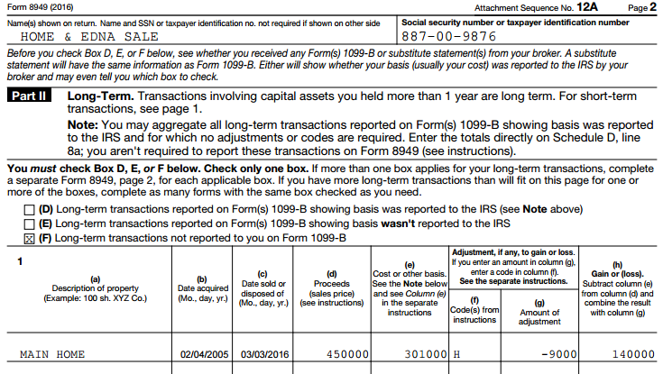
03/03/2018

This amount goes to Schedule D & 1040 line 13
This amount is from the general adjustments portion of the worksheet

Example

Automatically generated 8949 for Sale of Main Home with TP and SP who qualify for the exclusion.

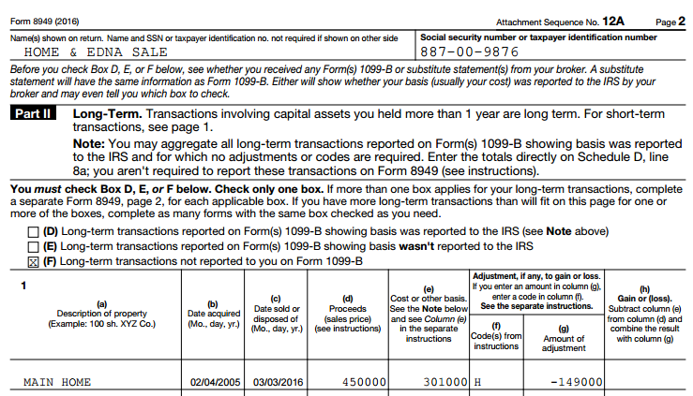
03/03/2018

Exclude Some/All of the Gain from the Sale of Your Main Home
This amount includes amounts from the general adjustments portion of the worksheet plus any excluded amounts

.

Example
Form 8949 after manually completing the capital gains transaction of a loss sales that must be reported because the TP received a 1099-S.

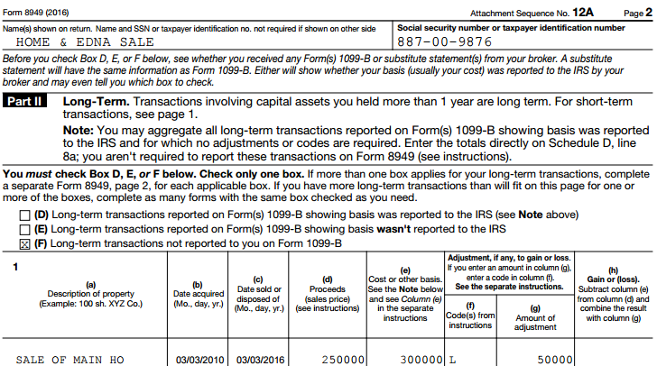
03/03/2018
Nondeductible loss other than a Wash Sale

